The BP Claims Process: A Detailed Guide

Beginning June 11, 2012, anyone who suffered losses or injuries related to BP’s 2010 Gulf Coast oil spill that had not already accepted a final settlement from the former Gulf Coast Claims Facility (GCCF) will begin filing under the new claims process.

This new claims processing system was set up under the terms of a settlement that was reached in hopes of avoiding a lengthy trial, as there were thousands of health and economic damage claims filed by individuals and businesses affected in the disaster. This settlement was approved by U.S. District Judge Carl Barbier and was uncapped, meaning there is no limit on how much money will be made available to pay damages. BP, however, estimates their total costs will be approximately $7.8 billion. The settlement does not resolve claims from federal, state or local governments. "They're attempting to negotiate their fees," said Daniel Becnel, a Louisiana tort attorney representing multiple clients who have filed claims with Kenneth Feinberg and the Gulf Coast Claims Facility (GCCF). Although courts have limited legal fees to 6 percent so far, "they (lawyers) want an open-ended claim fund."

There are two types of claims that can be filed under the new settlement. The first type is for anyone who experienced economic losses as a result of the oil spill and the second is for those who suffered medical problems and physical injuries due to the oil spill. The settlement also includes the closure of the GCCF, which will be replaced with a new fund to be supervised by the court.

Like the GCCF, funding for the claims process would come from the $20 billion trust that BP has set aside. More than $8.1 billion has already been paid to claimants, businesses and government entities, according to officials from BP, and the settlement is expected to cost about $7.8 billion, a figure that includes a $2.3 billion commitment to the Gulf seafood industry.

While this new settlement is one of the largest class-action settlements in history, it could have cost BP much more in the end, had the case gone to trial. It is likely some of the claimants and their council considered the experiences of multiple Alaskan fishermen before making their decision to settle out of court. In the wake of the Exxon Valdez oil spill, Alaskan fisherman filed suit against the oil corporation, however, the 20-year-litigation became an equal tragedy for the fishermen.

How the New System is Different

On March 8, 2012, after the parties came to an agreement-in-principle, the court ordered a transition process be put in place to handle claims until the new settlement program was established. The transition process evaluated claims under the same protocols and methodologies as the GCCF, with certain changes described in the transition order. The transition process was closed once the new program opened on June 4, 2012. As a result, the settlement program began accepting and processing claims pursuant to the terms of the settlement agreement.

The most valuable benefit from the new filing system is that the massive amount of corruption under Feinberg has been eliminated. The new process will use different algorithms to determine how much compensation each claimant is entitled. Feinberg’s practices were turning away mass numbers of people who, upon further inspection, had a valid reason to file and receive compensation.

Another benefit of the new program is that it will allow claims forms to transition through a review committee and receive a ruling faster than the Feinberg BP claims. This allows those who are accepted to immediately receive their financial compensation, while blocking those who would forge information in order to file a BP claim. For those who have legitimate claims that have previously been denied, they can quickly reapply and get on their feet faster with financial support. The new procedures, working alongside the claimant assistance centers in the Gulf Coast region, will allow victims to inquire as to the eligibility rules, prices and other regulations by which they must adhere if they are to receive benefits.

In addition, the new program will grant state and local government greater control over the claims process and help to decrease fraudulence. Without strict laws in place, BP claims are often turned down without justification, leading to a high number of claims of fraud.

More claimants, or would-be claimants, could seek legal representation for their dealings with the fund. Before the new system was implemented, fewer than 3 percent of those people filing claims had their own lawyers. Plaintiffs' attorney Daniel Becnel, who heads a 21-lawyer firm based in Reserve, Louisiana, said his firm “has taken on hundreds of new clients in the days following Barbier's ruling - most of them looking for help bargaining with the claims fund.”

Those who received a final payment through the GCCF are not eligible to have claims reviewed under the new criteria. Those who decided to take the final payment signed a release form relieving BP of all future claims. Those who have accepted an interim payment, not a final payment, would be able to submit claims.

Because this new settlement does not resolve all private claims against BP regarding the Deepwater Horizon Incident, BP has also set up a new OPA Claims Process to handle claims that are excluded from the settlement. This would be for claimants who are not class members or who choose to opt out of the settlement.

Two Types of Claims

Under the new system, there are two types of BP claims that are being filed against the multinational oil company. These are Economic and Property Damages Settlement Claims and Medical Benefits Settlement Claims. For necessary reasons, it is vital for each claimant to know the proper category of their claims in order to file the necessary paperwork to receive compensation.

Economic and Property Damages

The Economic and Property Damages Settlement resolves certain economic loss and property damage claims related to the 2010 Deepwater Horizon oil spill. If included in this settlement, claimants could receive money if harmed by the oil spill in one or more of the following categories:

- Seafood Compensation Program  - Individual Economic Loss  - Individual Periodic Vendor or Festival Vendor Economic Loss  - Business Economic Loss  - Start-up Business Economic Loss  - Failed Business Economic Loss | - Coastal Real Property Damage  - Wetlands Real Property Damage  - Real Property Sales Loss  - Subsistence Loss  - VoO Charter Payment  - Vessel Physical Damage

Economic and Property Damage Claim Examples

The following are details of the acceptable circumstances that would warrant an approved claim for Economic and Property Damage:

- Economic Damage Claim
Economic Damage is a loss of profits, income, or earnings suffered by an individual or business because of the Deepwater Horizon oil spill. Economic Damage does not include loss of profits or earnings or damages for injury that are related to other types of damages.
- Seafood Compensation Program
The Seafood Compensation Program covers damages suffered by commercial fishermen, seafood crew, or seafood vessel owners who owned, operated, leased, or worked on a vessel that was home ported in the Gulf Coast Area anytime from April 20, 2010 to April 16, 2012. In addition, the program covers fishermen who landed seafood in the Gulf Coast Areas between the dates of April 20, 2009 and April 16, 2012. It also covers damages suffered by oyster leaseholders and Individual Fishing Quota ("IFQ") owners. This Seafood Compensation Program does not apply to claims filed that relate to fishing, processing, selling, catching, or harvesting of menhaden (or "pogy") fish.
- Subsistence Damage Claim
Subsistence Damage is a loss of subsistence use of natural resources arising from the Deepwater Horizon disaster. This includes damages suffered by people who rely on fishing or hunting to harvest, catch, barter, consume, or trade natural resources located in the Gulf Coast (including Seafood and Game) in a traditional or customary manner, to sustain their basic personal or family dietary, economic security, shelter, tool, or basic clothing needs. This program was also affected through subsistence resources that were diminished/restricted as a result to the Deepwater Horizon Incident.
- VoO Charter Payment Claim
This claim category addresses damages suffered by people or businesses who registered vessels to participate in BP's Vessels of Opportunity ("VoO") program, executed a VoO Master Vessel Charter Agreement with BP, Lawson, USMS, USES, DRC, or any other BP subcontractor as Charterer, and completed the initial VoO training program. VoO participants can make VoO Charter Payment Claims regardless of whether they were directed or asked to work under the program.
- Vessel Physical Damage Claim
A Vessel Physical Damage Claim covers the physical damage to a vessel that resulted from the Deepwater Horizon oil spill or certain types of response clean-up operations. This would include the cost of removal of equipment and rigging added to the vessel as part of the recovery activities.

- Coastal Real Property Damage Claim
Individuals and Entities who owned/leased property or boat slips located in the Coastal Real Property Claim Zone from the dates of April 20, 2010 to December 31, 2010 can make a Coastal Real Property Damage Claim for damage to that property.

In addition, owners of real/personal property located in the Coastal Real Property Claim Zone that was physically damaged as a result of the Deepwater Horizon Incident response clean-up operations can make claims for the damage to property.

To see if a property is within the Coastal Real Property Claim Zone, view the Coastal Real Property Claim Zone Map. Inclusion in the Coastal Real Property Claim Zone does not mean that properties are automatically eligible for benefits.
- Real Property Sales Damage
Real Property Sales Damage is the economic loss suffered by sellers of residential property located in a specific geographic area, who sold their properties at a lower price because of the Deepwater Horizon Incident. In order to file a successful Real Property Sales Damage claim, claimants must have owned the property on April 20, 2010, and the sale of the property must have closed between April 21, 2010 and December 31, 2010. If the sales contract was executed before to April 21, 2010, the property sales price must have been reduced because of the Deepwater Horizon Incident. Real Property Sales do not include transfers from borrowers to lenders as part of a foreclosure or a similar process.

To see if a property is within the Real Property Compensation Zone, view the Real Property Compensation Zone Map. By itself, inclusion in the Real Property Compensation Zone does not mean that properties are eligible for benefits.

- Wetlands Real Property Damage

Individuals and Entities who owned wetlands real property located in certain geographic areas at any time between April 20, 2010 and April 16, 2012, can make claims for Wetlands Real Property Damage. If you have property located in the Wetlands Real Property Compensation Zone, you could receive a Settlement Payment depending on whether the property is considered oiled or non-oiled and what the acreage is.

In addition, owners of real or personal property located in the Wetlands Real Property Compensation Zone that was physically damaged in connection with the Deepwater Horizon Incident response clean-up operations can make claims for that physical damage to real or personal property.

To see if a property is within the Wetlands Real Property Compensation Zone, view the Wetlands Real Property Compensation Zone Map. By itself, inclusion in the Wetlands Real Property Compensation Zone does not mean that properties are eligible for benefits. Claimants must file a Wetlands Real Property Damage Claim Form in order to receive benefits under this category.

Medical Claims

This type of claim covers qualifying people who lived in the United States as of April 16, 2012, who were either “Clean-Up Workers” between April 20, 2010 and April 16, 2012; or lived in particular beachfront areas (Zone A) for at least sixty days between April 20, 2010 and September 30, 2010 (“Zone A Resident”), and have had a “Specified Physical Condition” prior to September 30, 2010; or lived in “Zone B” (specified wetlands) for some time on each of at least sixty days between April 20, 2010, and December 31, 2010 (“Zone B Resident”).
The Medical Settlement Web Site published the detailed maps seen below to help claimants determine whether a geographic location may be included in one of these zones. In general, the zones include certain beachfront areas within at least 1/2 mile of the water and wetlands areas within at least 1 mile of the water.
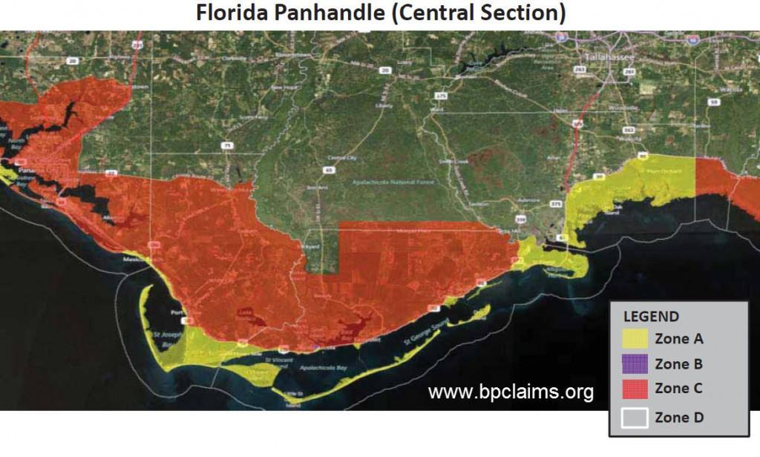
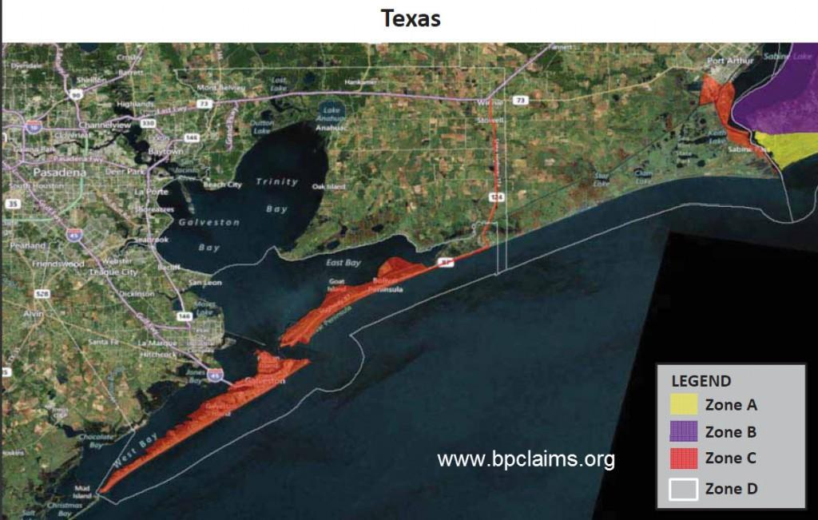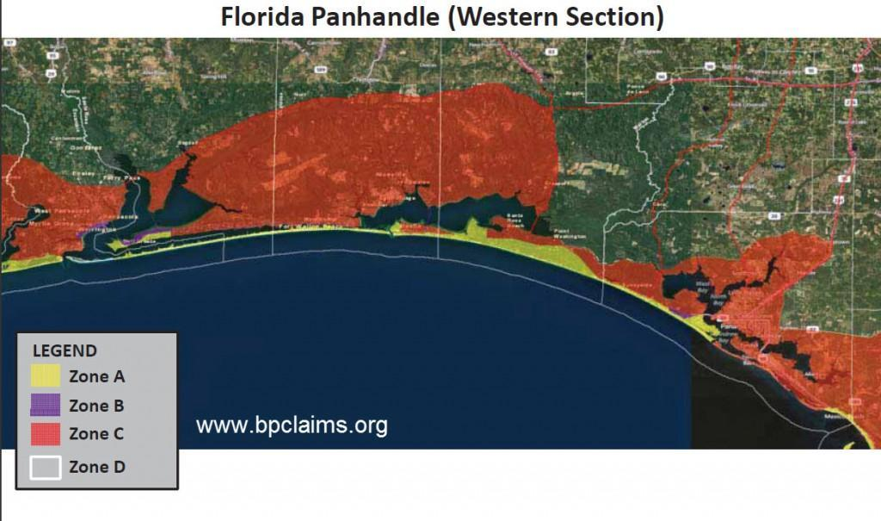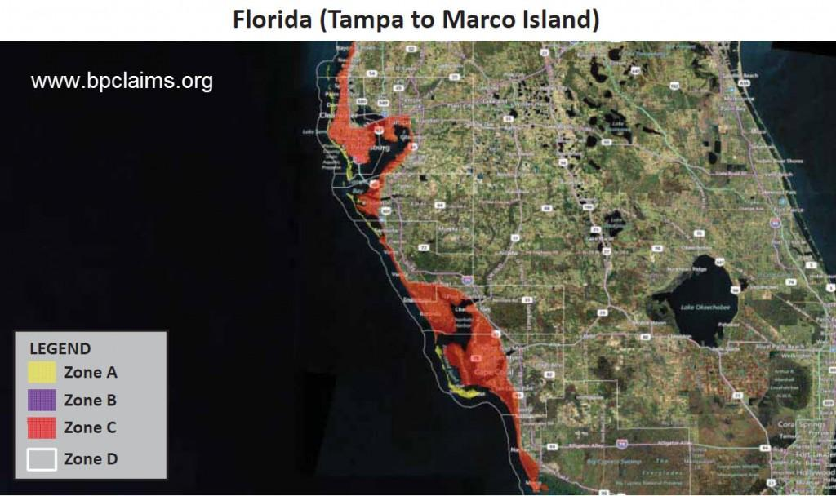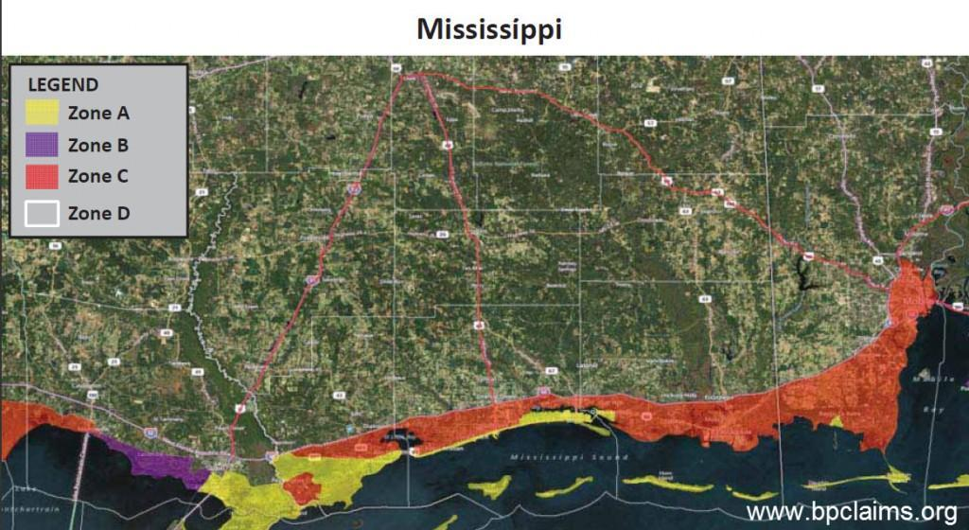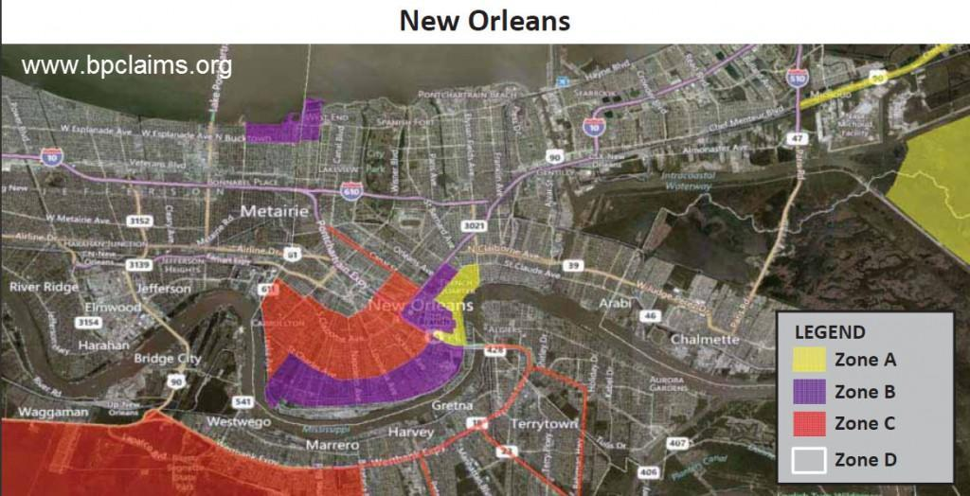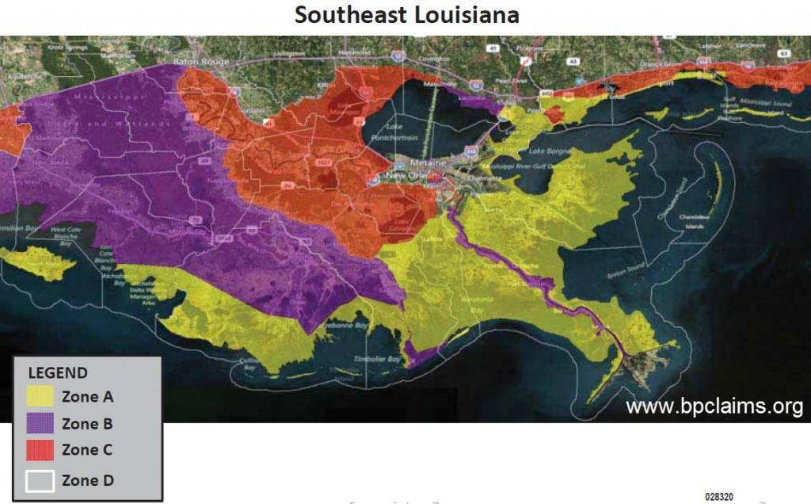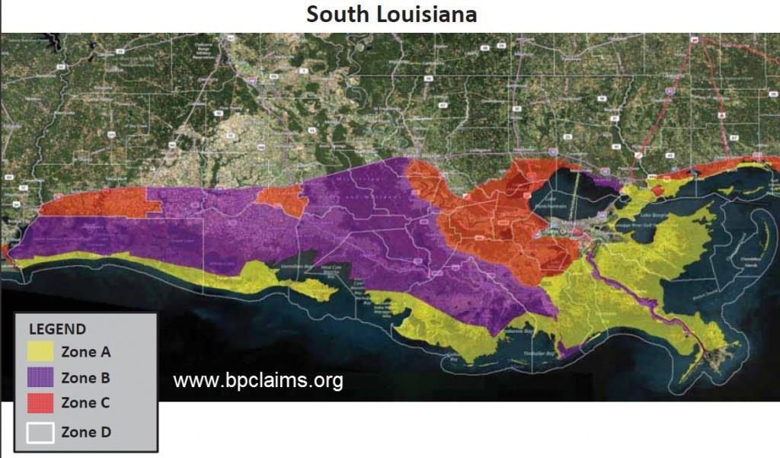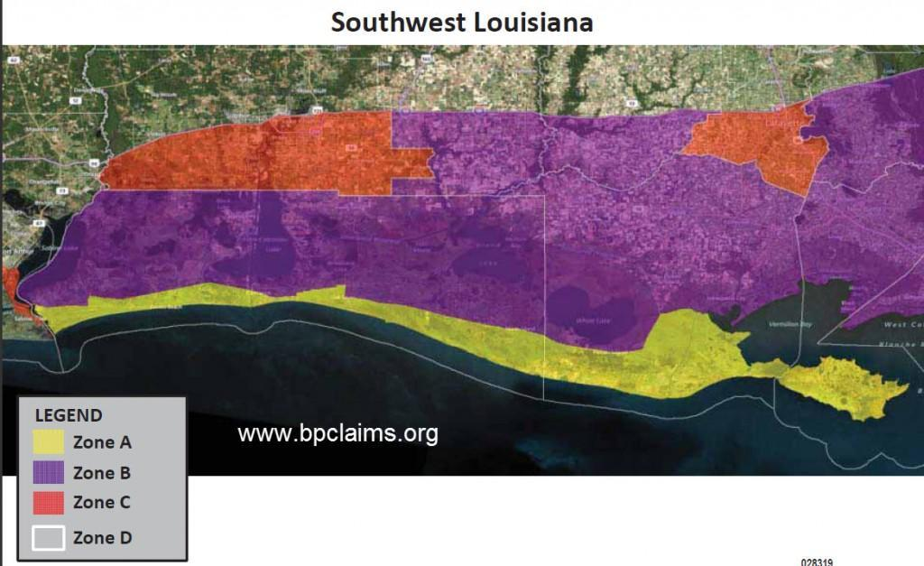

Benefits of the Medical Claims Process

The Medical Benefits Settlement will provide the following to claimants: 1) a compensation program for Specified Physical Conditions; 2) a Periodic Medical Consultation Program; and/or 3) a provision of Back End Litigation Option process for Later-Manifested Physical Conditions.

One extremely valuable benefit of the BP Medical Claims Process is the medical coverage. This coverage includes hospital care, medical exams, medical testing supplies, medical supplies for health conditions, medications, and continued tests over time. If claimants have cancer or a permanent, disabling health injury, they will need to report to the hospital monthly for checkups, routine tests, and so on. BP must compensate these victims for their medical expenses.

Another medical benefit is back-end medical conditions. Though some claimants may not experience immediate injuries or signs of illness post-disaster, they may begin to experience complications several years later in which doctors believe is a direct result of exposure to gasoline, oil, and other toxic chemicals present at the scene of the disaster. Claimants are entitled to 21 years of medical examinations.

To request Specified Physical Condition and/or Periodic Medical Consultation Program benefits, claimants must complete and submit a proof of claim form. Claimants will also need to include supporting documents for the Proof of Claim Form to be accepted. Claimants may elect to complete and submit a Proof of Claim Form 1) by requesting a notice packet and then returning the Proof of Claim Form via mail OR 2) by downloading the PDF Proof of Claim Form available at the Deepwater Horizon settlement site, then returning it via mail.

Additional Benefits for Medical Settlement Claimants

In addition to the Benefits described above, the Settlement created a Gulf Region Health Outreach Program for the benefit of Class Members and the general public. This Program consists of integrated projects to strengthen healthcare capacity and increase health literacy in the Gulf Coast areas of Louisiana, Mississippi, Alabama, and the Florida Panhandle. An on-line library of health and environmental-related materials pertaining to the Deepwater Horizon Incident is also being funded.

The medical settlement also creates a "Gulf Region Health Outreach Program," aimed at strengthening healthcare capacity and increasing health literacy in Gulf Coast areas of Louisiana, Mississippi, Alabama and the Florida Panhandle. The program will be available to class members and the general public.

BP will provide $105 million for grants in the four states in order to expand and improve access to health care in underserved areas, address behavioral and mental health needs, train community health workers, and expand and improve environmental health expertise. Funding for that program will begin after preliminary approval of the proposed settlement. That program will be overseen by a Gulf Region Health Outreach Program Coordinating Committee, which will include representatives from each of the programs and independent members.

BP also will fund a publicly accessible online library of health and environmental materials related to the oil spill and response activities.

Payments to individuals would be based on their status as a clean-up worker or resident of either of the coastal zones, whether their specified physical condition is acute or chronic, and the proof they submit of their illness to the claims administrator.
The program is uncapped, according to the agreement, with payments ranging from $1,300 to $60,700 for clean-up workers, and from $900 to $36,950 for Zone A and B residents. An additional "enhancer" would be available for overnight hospitalization and payment of actual hospital expenses in most cases.

The conditions covered range from eye, respiratory, skin, neurological and odor-related maladies. Clean-up workers can also be compensated for heat-related conditions that occurred during or immediately following a work shift.

Under the periodic medical consultation, those who qualify are entitled to an initial medical consultation, followed by additional visits every three years during the life of the program. The claims administrator will establish a network of medical services providers for the visits, selected based on their location near class members and their ability to provide the consultation services. A call center and web site will be set up for scheduling appointments.

Under the option to file a claim for illnesses that occur in the future, class members can either participate in the program or file for assistance under state workers' compensation laws or the Longshore and Harbor Workers' Compensation Act.

Those later claimants must notify BP of the illness within 4 years of first diagnosis of the condition or with 4 years of the settlement approval, whichever is later. BP then has the option to request mediation, and if the company does not agree to the results, the claimant has the right to file a lawsuit against BP. In such a lawsuit, the claimant won't have to prove again that they were exposed to oil or dispersant or that BP was responsible for the Deepwater Horizon accident.

The Lawyers Representing Claimants

The following list provides contact information for the Court appointed lawyers appointed to assist claimants with claims:

- Stephen J. Herman (Lead Class Counsel),
820 O’Keefe Avenue New Orleans, LA 70113
504.581.4892
sherman@hhklawfirm.com

- James Parkerson Roy (Lead Class Counsel),
556 Jefferson Street, Suite 500, P.O. Box 3668,
Lafayette, LA 70501
337.593.4190
http://www.wrightroy.com

- Brian H. Barr
316 S Baylen St, Pensacola, FL 32502
850.435.7045
http://www.levinlaw.com

- Jeffery A. Breit,
600 22nd Street, Suite 402
Virginia Beach, VA 23451
757.622.6000
www.breitdrescher.com

- Elizabeth J. Cabraser
275 Battery Street 29th Floor
San Francisco, CA 94111-3339
415.956.1000
ecabraser@lchb.com

- Philip F. Cossich, Jr.,
8397 Hwy. 23, Ste. 100
Belle Chasse, LA 70037
504-394-9000
www.cossichlaw.com

- Robert T. Cunningham,
1601 Dauphin Street
Mobile, AL 36604
251.471.6191
rtc@cunninghambounds.com

- Alphonso Michael Espy,
188 East Capitol St, Suite 777
Jackson, Mississippi 39201
www.mikespy.com

- Calvin C. Fayard, Jr.,
519 Florida Ave.,
Denham Springs, LA 70726
225.664.4193

- Robin L. Greenwald
Weitz & Luxenberg
700 Broadway
New York, NY 10003
212.558.5500
RGreenwald@weitzlux.com

- Ervin A. Gonzalez,
The Law Firm of Colson Hicks Eidson
255 Alhambra Circle, Penthouse
Coral Gables, Florida 33134
305.476.7400
ervin@colson.com
- Rhon E. Jones
218 Commerce Street
Montgomery, AL 36104
800.898.2034
rhon.jones@beasleyallen.com

- Matthew E. Lundy
501 Broad Street
Lake Charles, LA 70601
337.513.0292
www.lundylawllp.com

- Michael C. Palmintier
618 Main Street
Baton Rouge, Louisiana 70801-1910
225.344.3735
http://www.palmintierlaw.com

- Joseph F. Rice
940 Gravier St.
New Orleans, LA 70112
504.648.1480
jrice@motleyrice.com

- Paul M. Sterbcow,
2615 Pan American Life Center 601 Poydras Street
New Orleans, Louisiana 70130
504.588.1500
kcourtney@lksalaw.com

- Scott Summy,
3102 Oak Lawn Avenue\, Suite 1100
Dallas, TX 75219
214.521.3605
ssummy@baronbudd.com

- Mikal C. Watts and
4 Dominion Drive, Bldg. 3, Suite 100,
San Antonio, Texas 78257
800.294.0055
contact@wgclawfirm.com

- Conrad S.P. Williams (Medical Class Counsel to represent the Medical Class Members)
435 Corporate Drive
Houma, Louisiana 70360
985.876.7595
www.williamslawgroup.org

Claimants will not be charged for the services of these lawyers. Those who want to be represented by their own lawyer may hire one at their own expense.

New Office Locations for Claims

Patrick Juneau, the Claims Administrator appointed by U.S. Federal District Court Judge Carl Barbier to oversee the court-supervised claims administration for the Deepwater Horizon settlement, has announced the opening of eighteen new Claimant Assistance Centers across the Gulf Coast.

A Claims Administration Panel has been set up to address and attempt to resolve any issues that may arise concerning the Settlement Program. If an issue cannot be resolved by the Claims Administration Panel, it will be referred to the Court for resolution.

The eighteen Claimant Assistance Centers will be located in the following states:

Alabama

Gulf Shores
Palm South Plaza
3501 Gulf Shores Parkway
Suites 4, 5, and 6
Gulf Shores, AL 36542

Mobile
Skyland Shopping Center
3976 B Government Road
Mobile, AL 36693

Bayou La Batre
Northfield Shopping Centre
13290 N. Wintzell Avenue
Bayou La Batre, AL 36509

Florida

Apalachicola
194 14th Street
Suite 106
Apalachicola, FL 32320

Clearwater
2551 Drew Street
Suite 303
Clearwater, FL 33765

Fort Walton Beach
348 Miracle Strip S.W. Parkway
Suite 34
Fort Walton Beach, FL 32548

Naples
14700 Tamiami Trail N
Rt. 41
Naples, FL 34110

Panama City Beach
7938 Front Beach Road
Panama City Beach, FL 32408

Pensacola
7555 Hwy 98 West
Suites 3 & 4
Pensacola, FL 32506

Louisiana

Cut Off
16263 E. Main Street
Tarpon Heights Shopping Center
Unit 2
Cut Off, LA 70345

Grand Isle
3811 LA 1
Grand Isle, LA 70358

Gretna/Harvey
2701 Manhattan Blvd.
Suite 12
Harvey, LA 70058

Houma
814 Grand Caillou Road
Suites 2 & 3
Houma, LA 70363

Lafitte
2654 Jean Lafitte
Lafitte, LA 70067

New Orleans East
9671 Chef Menteur Hwy.
New Orleans, LA 70127

Mississippi

Bay St. Louis
1171 Highway 90
Bay St. Louis, MS 39520

Biloxi
15812 Lemoyne Boulevard
Biloxi, MS 39532

Texas

Bridge City
2017 Texas Ave.
Bridge City, TX 77611

Additional Contact Information for Claimants

While these Claimant Assistance Centers will be available for "walk-up" service, persons and businesses filing claims can do so online by going to www.deepwaterhorizoneconomicsettlement.com

A toll-free number - 1-866-992-6174 - has been established in the case. Claimants should refer to the case as follows: “In re: Oil Spill by the Oil Rig "Deepwater Horizon" in the Gulf of Mexico on April 20, 2010, MDL No. 2179.”

There is also an established website, DeepwaterHorizonSettlements.com, where notices, individual settlement agreement information and other documents may be obtained.

Important Deadlines for Claimants

Pursuant to the authority provided to the Court in Sections 8.2.1 and 28.1 of the Amended Deepwater Horizon Economic and Property Damages Settlement Agreement (Rec. Doc. 6430-1), the Court makes a one-time extension by modifying Paragraph 39 of its May 2, 2012 Preliminary Approval Order regarding the Economic and Property Damages Settlement Agreement (Rec. Doc. 6418) to extend the deadline by which requests for exclusion (requests to opt-out) must be postmarked from October 1, 2012 to November 1, 2012.

Additionally, pursuant to the authority provided to the Court in Sections XI.E and XXX.I of the Amended Deepwater Horizon Medical Benefits Class Action Settlement Agreement (Rec. Doc. 6427-1), the Court makes a one-time extension by modifying Paragraph 29 of its May 2, 2012 Preliminary Approval Order regarding the Medical Benefits Class Action Settlement (Rec. Doc. Case 2:10-md-02179-CJB-SS Document 7176 Filed 08/27/12 Page 1 of 2 - 2 - 6419) to extend the deadline by which requests for exclusion (requests to opt-out) must be postmarked from October 1, 2012 to November 1, 2012.
New Orleans, Louisiana, this 27th day of August, 2012.

Resources:

Deepwater Horizon Economic Settlement
www.deepwaterhorizoneconomicsettlement.com

Deepwater Horizon Medical Settlement
www.deepwaterhorizonmedicalsettlement.com

Deepwater Horizon Settlement
www.deepwaterhorizonsettlement.com

